**RESULT EXERCISE 1 – SLOT 3**

**Name: Bùi Thị Tuyết Nhi**

1. **List all categories**

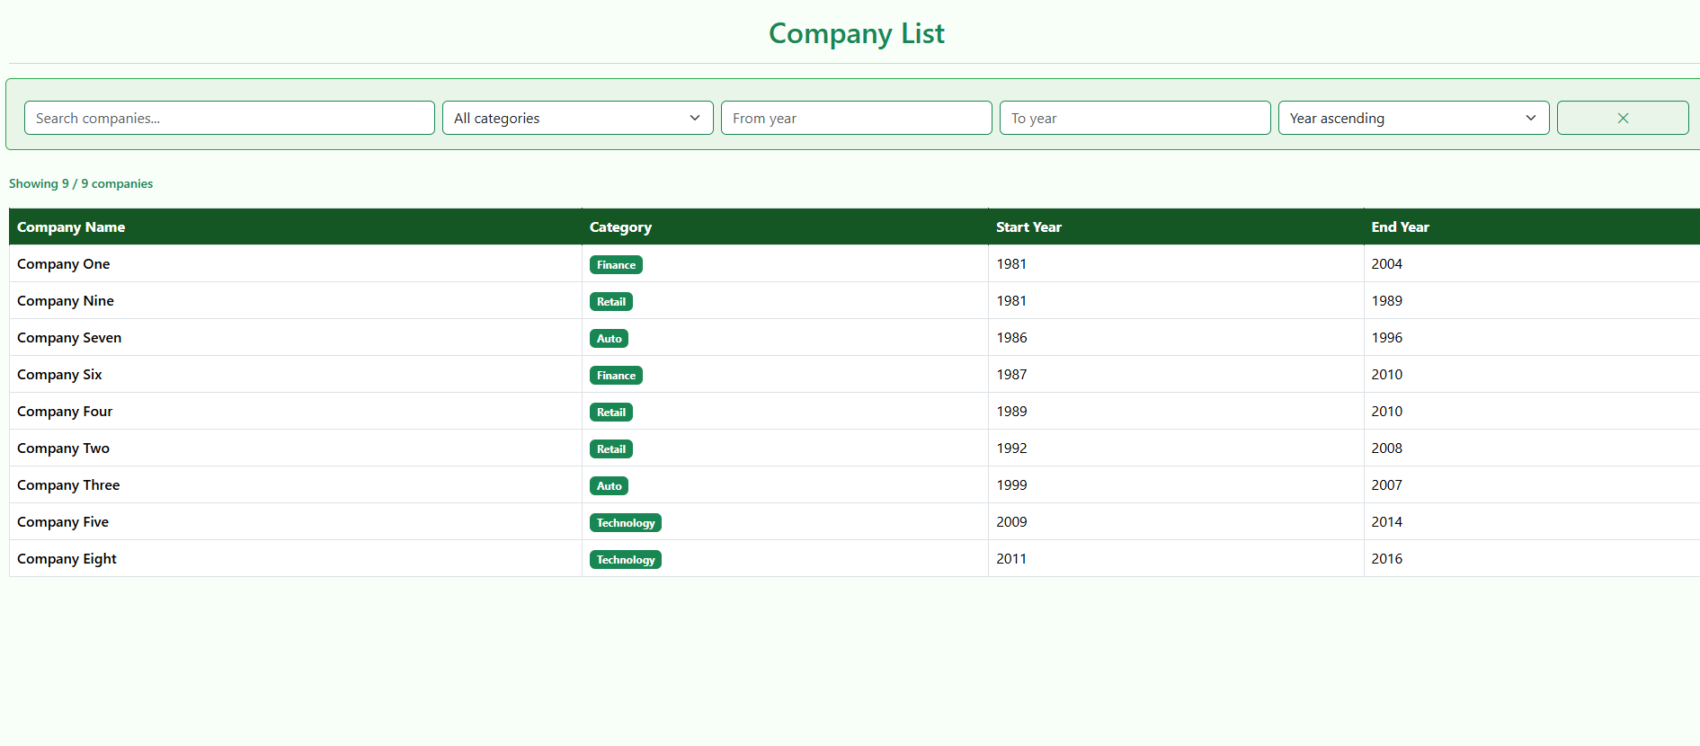

1. **Search by company name**

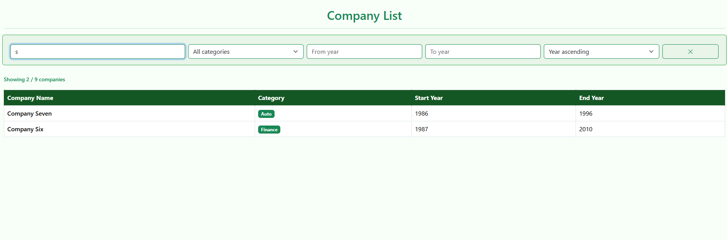

1. **Filter by categories**

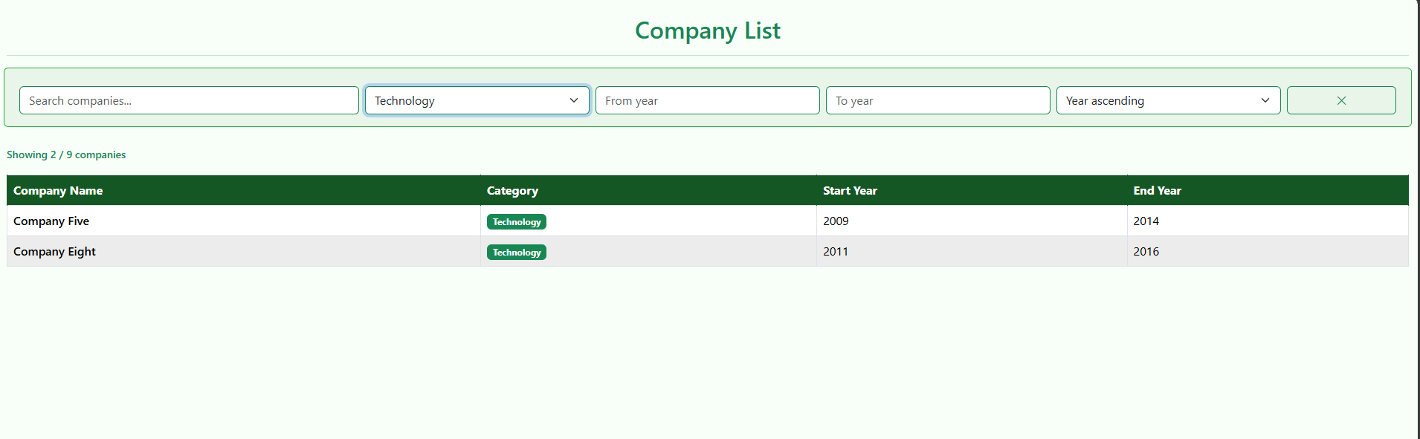

1. **Filter by start - end year**

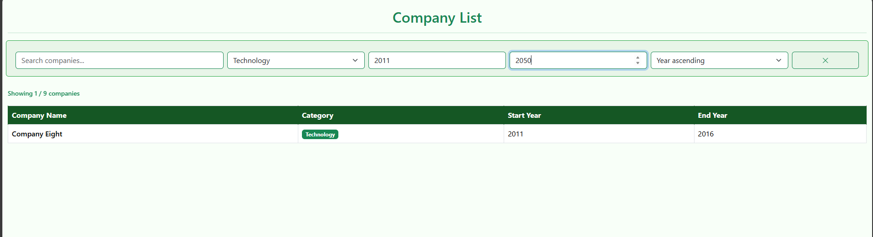

1. **Search no result**

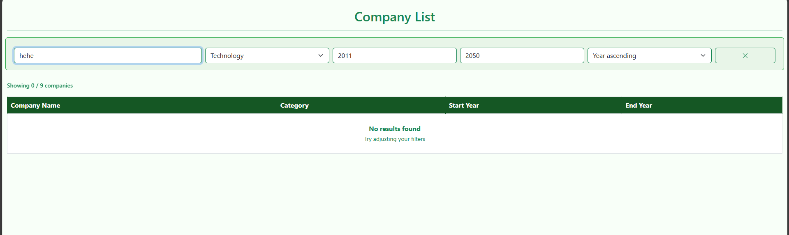

1. **Sort By year**

